**Conversation Guide: Digital Health Modernization Discovery Research - Caregiver Group**

**Bold text identify the moderator’s questions.**

*Text in italics are Jen’s observations and interpretations of the participant.*

[Text in brackets are interpretations in participants’ direct quote.]

**Background (5 minutes)**

To get started, I’d like to get a little background information about you, and your experience with the VA.

1. **Can you tell me a little bit about yourself?**

I joined in 2008 deployed to Afghanistan, sustained a few traumatic brain injuries [TBI] over there. Came back with PTSD and all that good stuff.

I have been going to the VA a couple years after I was out. Didn’t really know much about it in the beginning. My wife finds out most of it for me.

I have been receiving continuous care for PTSD and my TBI. I was just diagnosed with something called POTS I guess related from the TBI. Or TBIs excuse me.

I have done physical therapy through the VA. Been through a lot of neurology appointments, MRIs, I think it’s MRAs.

I am 100 percent disabled through the VA.

I am very bad about sharing my past I guess. *Participant chuckles.*

Is there something specific thinks you wanted to know. I am bad at that part I guess.

**Located**:

Upstate NY in Poolville NY.

**How long have you been there**:

8 years. And I was in Florida and Washington before that. Since I was out of the Army. I was stationed here in Fort Drum which is 20 minutes from where I live.

1. **When did you leave the Army:**

2011

**What do you do in the spare time:**

Take care of my kids. It’s winter time so isn’t much for hobbies right now. I fish and hunt. I try to stay active.

**Tell me a little about your kids. How old are they**:

A 5 year old and a 1.5 year old. The 5 year old is at school right now. The 1.5 year old is awesome but a monster though. Then the 5 year old is doing well in school, she takes after her mom, she’s smart so that’s good.

1. **Other things you get from the VA outside of disability and health care?**

My wife is my caregiver. So she is through the caregiver program.

**What does the caregiver allow her to receive from the VA:**

Because I am 100 percent I know she gets healthcare, schooling, stipend from the caregiver program. Then I know there is support groups for her if she were to need something like that.

If she were in here she could name off 100 other things. I think that’s it. The health care, the schooling, and the support groups.

**Is she currently in school:**

Yes, she is going for her bachelors in accounting something. *Participant laughs.* Bachelors of science majoring in accounting. Something like that.

**Going for her bachelors, receives healthcare, support groups through the VA, correct:**

Yes.

1. **What VA benefits does [Veteran] receive?**

I’ve been going through the independent living program. I am have been doing that too. They are working on a few things for the house to make things easier. Grab bars for the shower. Because with my TDIs I get dizzy and pass out.

**That is set up through the independent living program:**

Yes

1. **Does [Veteran] have any family members they claim as dependents?**

Yes. Children and wife as dependents.

**5.a. Do your children receive any benefits from the VA?**

I know they can get CHAMP VA but I don’t know that we signed them up for it. I actually don’t know.

I want to say they can get schooling benefits and stuff like that too.

My wife is extremely knowledgeable about this, I am just kind of here.

**Kids what do they use for healthcare:**

Medicaid. My wife she lost her job due to COVID so we had to switch over to that.

1. **Do you also manage any of your VA healthcare?**

I do. She just double checks everything I do.

I can get online and look at my records and stuff like that.

If there’s an appointment I need to set up. I do all of that she just double checks to make sure I am doing it right.

I try to take weight off of her shoulders.

**6.a. Where do you do that?**

Ebenefits and My HealtheVet.

They are automatic logins things I have them saved.

**How do you say you guys share that task. Does one of you do it more than the other in terms of setting up appointments:**

I have to talk to my doctors, they won’t really talk to her I guess. That part falls on me.

She makes sure it is actually happening. So if I need to see my primary doctor on a routine basis, like every year she will make sure I am setting up the appointments. And for my neurology appointments she makes sure I don’t miss them.

It is kind of I do that talking and she does everything else I guess.

**She’s kind of behind the scenes making sure things are running the way they should:**

Yes Ma’am.

**How does she check the appointments:**

I don’t know what she uses, I am not sure.

**Does she have access to your My HealtheVet**:

Yes Ma’am.

1. **Do you use any mobile apps to manage your health?**

I did. I had all of that on my last phone. But I broke my phone.

My brain is horrible I can’t remember the name of the app I was using.

It wasn’t VA related, it was from my cognitive therapist had me download. I can’t remember the name of it. I’m sorry. I haven’t gotten it on this phone yet.

7**.a. (If yes) What do you use them for?**

So I could start scheduling my own appointments. Or not to do that, but to put my appointments down. Like reminders and have notes from the doctors when I went in. Like if my wife couldn’t be there I could write down what was going on. Just to kind of be more independent with myself I guess. Or a tool I guess.

**Do you remember if you liked it or if it were useful:**

I did but I think I got lazy using it. Like I would forget to use it or write stuff down. So my wife started to have to pick back up. Then once I broke my phone I haven’t put it on the new one yet.

**Mental model of health at the VA (20 minutes)**

Now I’d like to hear about your experience first learning about VA benefits. **(10 minutes)**

1. **How did you learn about the health care available through the VA, and what was the process of applying for and accessing those benefits?**

My wife and I came back here from Washington State. I didn’t really know anything about the VA. I was in denial phase in admitting that I have issues.

We were homeless so we went to the homeless program for Vets here. The guy there pointed us to the VA and once I got into the VA and did everything with our primary doctor, like checking my physical health.

They put me with a physiatrist that kind of when I figured everything out. Put a name to everything, like PTSD, and I was able to kept seeing my primary doctor.

Then they sent me to neurology and that’s where the TBIs, I was able to put two and tow together on why I was getting dizzy all the time.

**So someone from a homeless shelter for Vets pointed you in the right direction:**

It wasn’t a homeless shelter. It was a guy who works with homeless vets. It was part of the VA, he works with the VA. I don’t remember who pointed us to him. I think it was an acquaintance.

1. **Tell me about the experience of the health care you receives through the VA**:

The psychology aspect is good; they work with you. They work with you. I like that it’s not like. I was in therapy before as a kid and I know what it was like as a non-Veteran. I didn’t like it because it was like breath and do yoga.

There it is more like, I don’t know how to explain it, they are geared toward Vets.

I am horrible with words I guess.

**The VA therapist could relate to you a little bit better and understands your background:**

Yes.

So that’s psychology.

The mental health part I am on medication for depression and anger.

My mental health doctor is good to because he was doubling as mental health doctor and psychologist all in one.

Physically, I kind of didn’t really take to the neurologist because I felt they were trying to blame everything on my PTSD. Like for my dizziness and passing out they would say for the longest time it was anxiety relate. They were kind of denying that I had TBIs.

And eventually I went to an outside neurologist and the first MRI they saw lesions on my brain that were related to the TBIs. So just kind of I made the decision to stay clear there.

Physical therapy I was doing for a while and they were sending me to an outside provider and you can only do that for a set amount of time.

I have been going in and out of cardiology. I don’t exactly know why I am going there but the neurologist keeps sending me there.

Overall I like the health care, I like going there, but like everything there can be problems. Like neurology.

My primary doctors changes every 6 months. I think it’s a lot of like doctors come in, I don’t know how they do it. They are training I guess and then move on to another place which kind of sucks.

I don’t know what else to say I guess.

My oldest (5 years old) daughter like to go hangout and talk to the old vets so she will go talk with them, and laugh with them and wonder why they are missing legs.

**You mentioned the VA were denying TBIs and you went to an outside neurologist**:

Yes, and for the longest time they wouldn’t sign off on that. Even with the - I don’t know when you were allowed to see outside providers they still had to sign off on it..

So I had to get an outside primary doctor just to have them refer me to go see an outside neurologist.

I kind of went above their heads.

**Do you remember when seeing the outside neurologist if you still see them:**

Yes, in Watertown. I think it is Watertown Neurology is what it is called. I can’t remember the doctors name.

**Does the VA cover them as well:**

No, I have Medicaid. My whole family has it now because my wife isn’t above the income.

1. **How would you explain a “disability rating” to a new Veteran?**

To me it I have all my limbs, so sometimes people look at me weird when I say I am disabled.

Do you want me to explain the different percentages?

**More broadly what does having a disability percentage get you:**

You can get healthcare for the rest of your life for whatever your injury is.

I guess that’s not true because you get healthcare for anything and everything now that I am disabled.

You can get it for even PTSD.

Anything related to your military past.

I know people that didn’t deploy that have disability ratings because they were injured before deployment.

**What I was hearing is you can get healthcare related to injury and non-physical things like PTSD:**

Yes. You can get other benefits, like the independent live, as well as benefits for your family.

1. **In your mind, is there a relationship between "disability" and "health care”?**

In what way do they like go together? Yeah I mean. I don’t understand the question.

**Does it seem like having a disability percentage impact health care at the VA or the other way around:**

I think if you don’t have a rating you, I think you can still go but I think you have to pay like regular insurance.

I feel like there is more out there if you have a rating.

Like they will pay for you to see outside providers if you wish. Or say like I do where you live an hour away from the main hospital where most of the doctors are. They will pay for someone up here. I’ve done that a couple times. Like with physical therapy.

I think the healthcare is probably better because you can see a variety of doctors.

I think that answers the question.

1. **When it comes to your health, what is the most important thing you need from the VA?**

A kick in the ass sometimes.

Just I guess, I get a lot of emotional support from my psychologist checking up in between appointments.

Just voicing that they are there is the biggest thing for a lot of guys. I know when we got out they make you do all these classes but you just want to get out, why am I doing all this, who cares, in one ear and out the other. And then when you get out it’s like oh crap.

I think they are better about it now. Letting you know that they are there.

I get more emotionally then physically from them.

**Therapist checks in in-between appointments. How does that work:**

Umm, kind of personal things.

Like suicide watch kind of.

So if something will pop up. So all the doctors at the VA can all see notes and stuff from other doctors, so if something pops up that’s she’s questioning or wants to know about she will call and ask her whatever. Or my mental health doctor will call and ask to talk to me about it just to see how things are going.

Or if I haven’t scheduled an appointment for a while to see my therapist, she will call to set one up. She will go out of her way to do that.

Kinda makes them more personal instead of just a doctor patient relationship.

1. **Do you have the appointments with your therapist on a regular basis or have to scheduled each time**:

So I schedule it then if I miss an appointment or have to cancel one, and then I don’t set it up that’s when she will call. Yeah.

Now I’d like to ask you how you manage information and tasks related to [Veteran's] health care. For each one, talk me through the steps you’d take. If there is something that you go online to complete, I may ask you to share your screen so I can see what you would do. **(10 minutes)**

**Tasks** Moderator should prompt about device usage if participant mentions digital tools or resources.

* **How would you reach out to your VA care team if you had a question?**

I have gone into chat group. I can’t remember if it’s HeatheVet or Ebenefits, but where you can talk to your doctors online.

I used to call. The guy who helped us, in the beginning I told you, he still works at the VA. If it’s a question I need answered right away I will call him.

But if it can wait I get online and ask one of my doctors.

I keep getting Ebenefits and My HealtheVet mixed up. So I can’t remember which one I get on there and chat with.

**Sounds like you can do that online or call Aaron directly**:

Yes Ma’am.

* **How would you refill a prescription you have with the VA?**

I usually call my doctor, my mental health provider.

We usually do that during appointments though because he will watch to make sure I am not reacting funny on my meds or not. We usually have an appointment a couple weeks before my meds run out, and he kind of asks me how I’m doing on them, and they’ll reorder them. Or see if I need change the dose.

* **How would you check the date of an appointment with your VA care team?**

Online.

**Would you be able to show us:**

I just bought this laptop for my wife. I think she may have it in here already, let me see. I don’t know if we’ve been on it on this laptop or note.

No we haven’t. And I am horrible with remembering what the login is real quick. If you need me on here I can ask her.

**That’s fine. I will share my share my screen. Does this look the website you normally use for health specifically:**

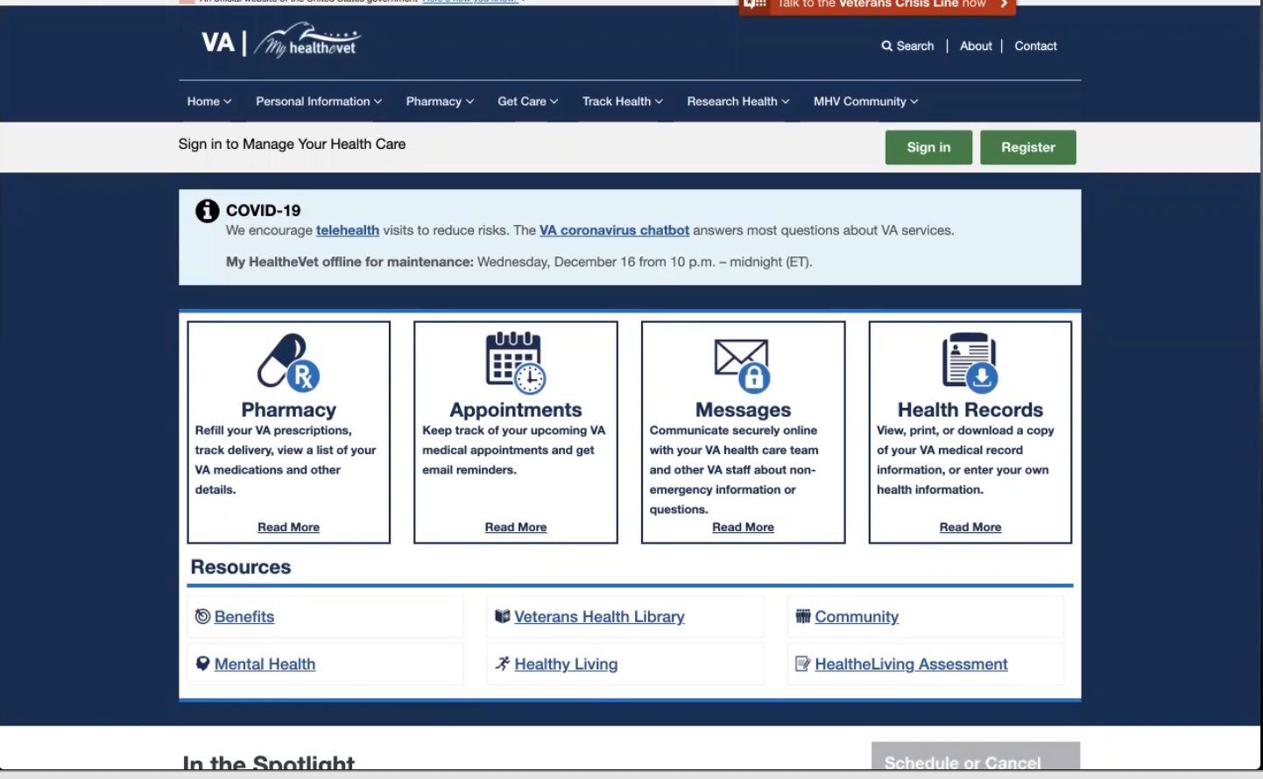

*Moderator shares screen on My HealtheVet home page.*

I normally do that on my other phone but yes that looks like it.

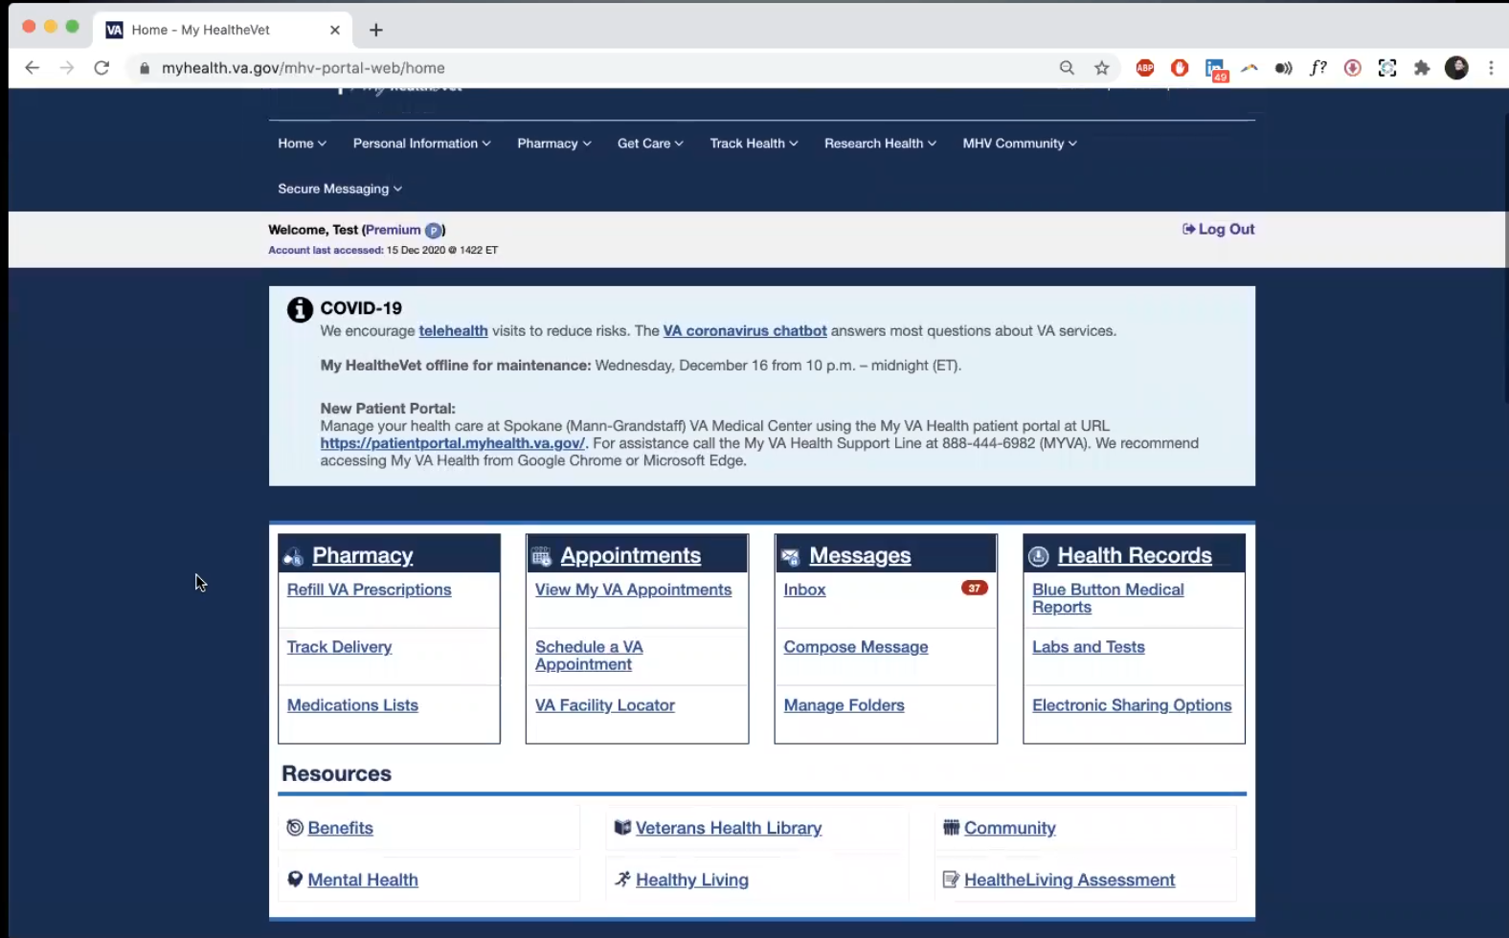

*Moderator logs in with test account to My HealtheVet and shows participant home page.*

**Does this look familiar:**

Yes Ma’am.

**If checking an appointment where would you find it:**

Where it says appointments, and view my appointments.

**Do you ever make appointments on here:**

I don’t think I have.

* **I think you said you send messages, is there anything else you use this website for**:

I have been to the doctor’s appointments. Like outside doctors appointments. And I can never remember what meds I am so I can go and look at my meds and stuff like that.

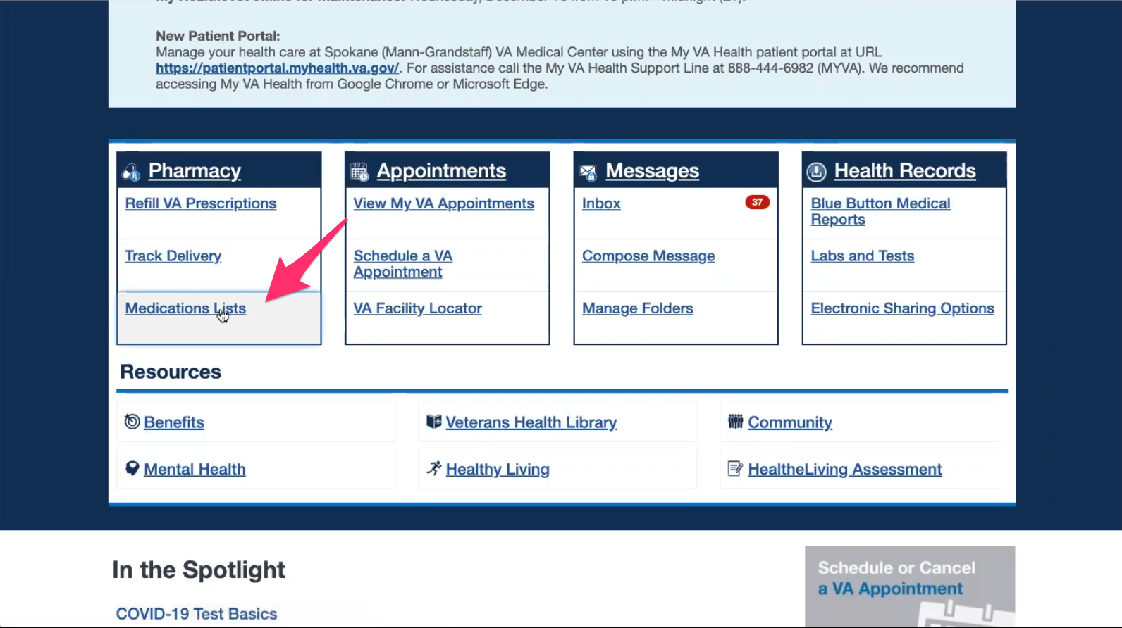

*Moderator hovers cursor over “Medication Lists” on home page under “Pharmacy” block.*

Yeah right there. Medication lists.

That way I can have access to the information because I never remember the doses and important information.

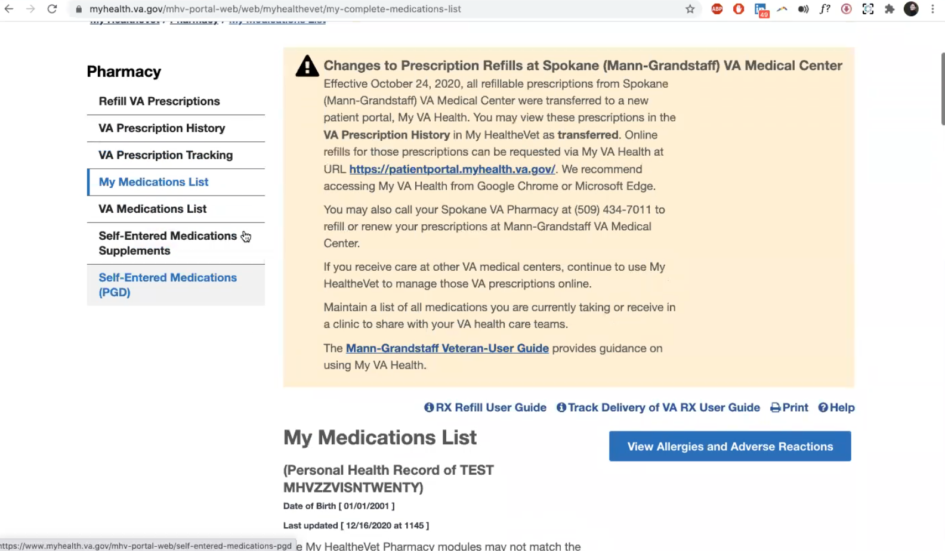

*Moderator clicks on “Medications List” link and show “My Medication List” page to Participant.*

**You mean if you see an outside doctor you use this too?**

No, if I go to a doctor outside like urgent care and they ask for the meds I am on. I don’t know so I just go on here and it’s right there.

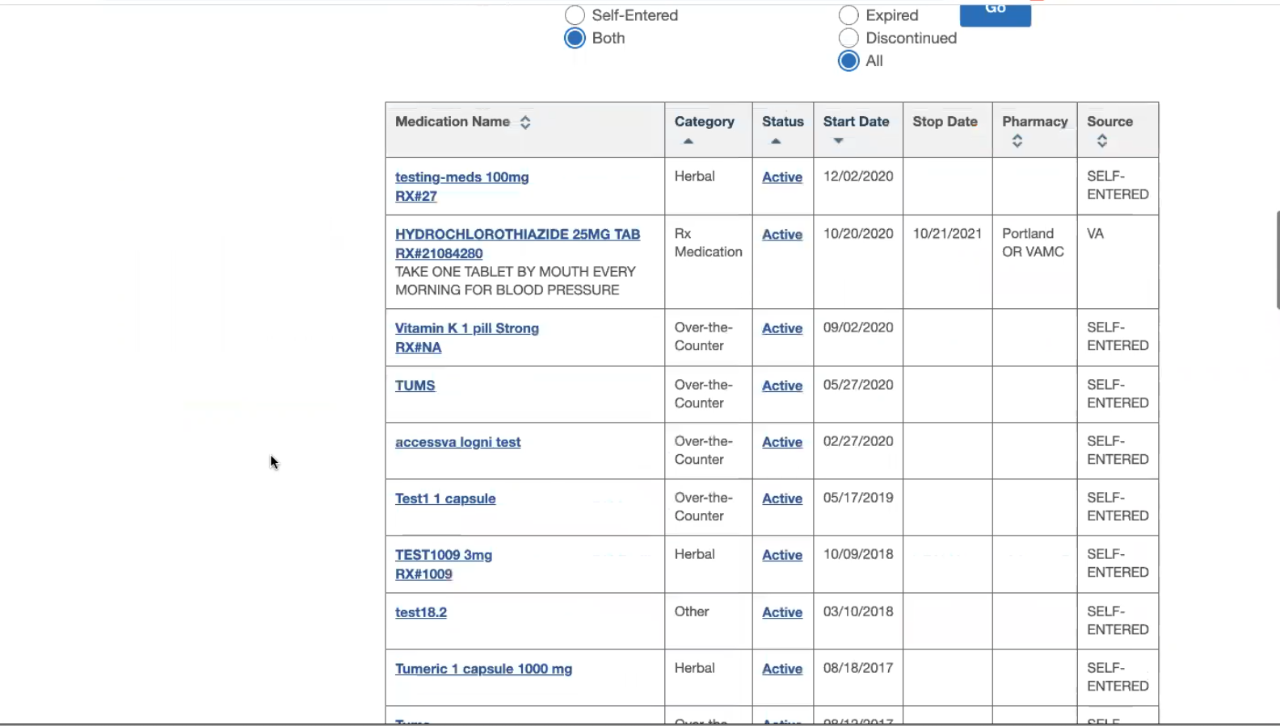

*Moderator scrolls down “My Medications List” page to show medications list table to Participant.*

**Is this list what it normally looks like:**

Umm something like that it has been a little bit since I have looked at meds on here.

* **Anything else**:

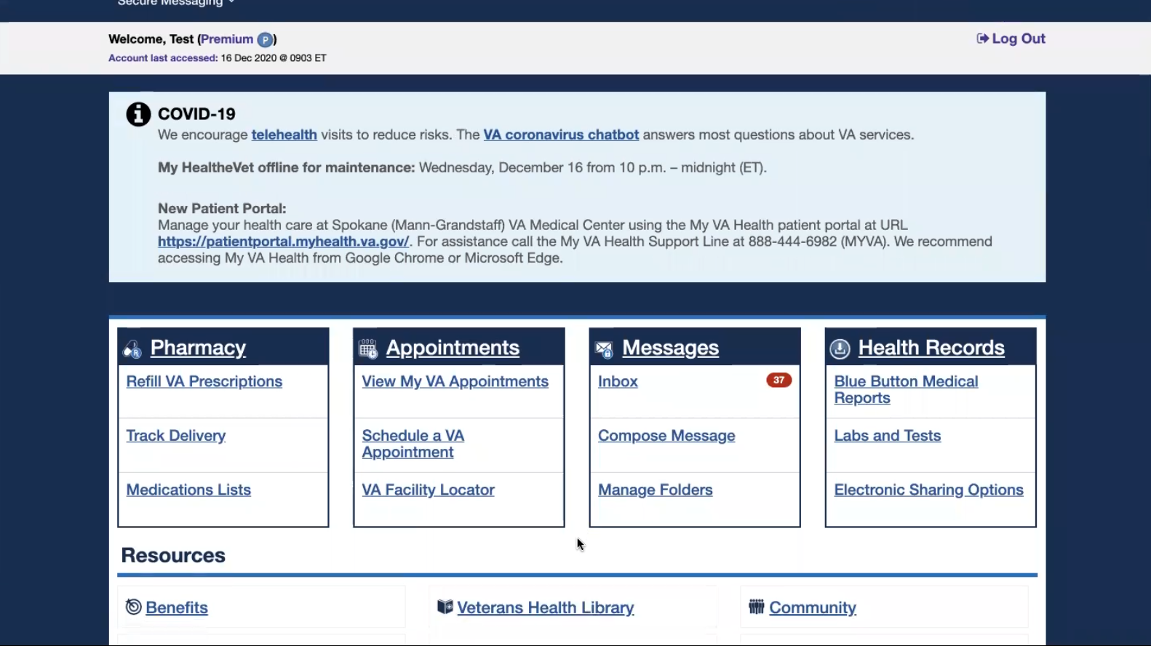

*Moderator goes back to home page of My HealtheVet.*

This looks like the site I see VA appointments and stuff like that.

For some reason I don’t know when an appointment is, I see the VA appointments here.

Is Ebenefits like this? I don’t know what I can never remember?

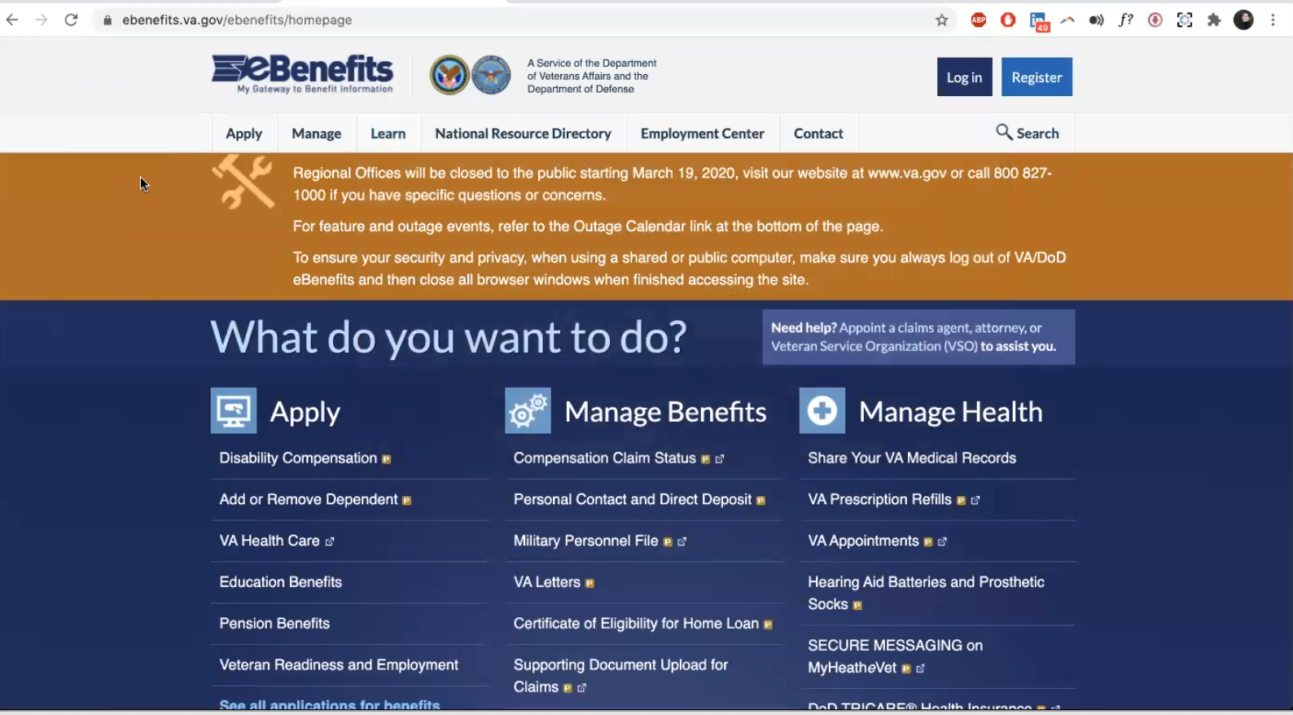

Moderator goes to Ebenefits website and shows Participant home page.

No. *Participant immediately says this on page load. Visual design seems to clue him that this site was not what he was wondering about.*

I mean kind of.

Yeah you can see your appointments and prescriptions but we use My HealtheVet more often.

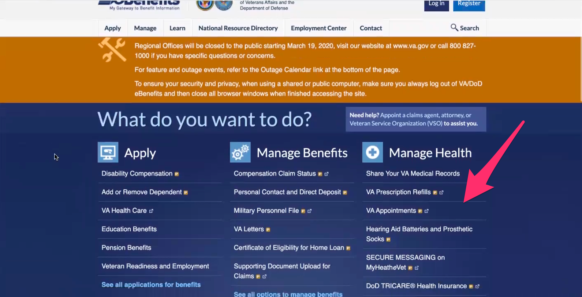

*Participant is referring to links under “Manage Health” heading on right column of page.*

**You said you can see your appointments:**

I think maybe I had an app with this in it or something.

**For appointments in particular for the app:**

Yeah.

* **You said you use Ebenefits for looking up records or documents**:

Yes, like past records. I am pretty sure this is where you can see the details from every appointment you’ve ever had and the notes from them.

* **I am seeing this link for benefits:**

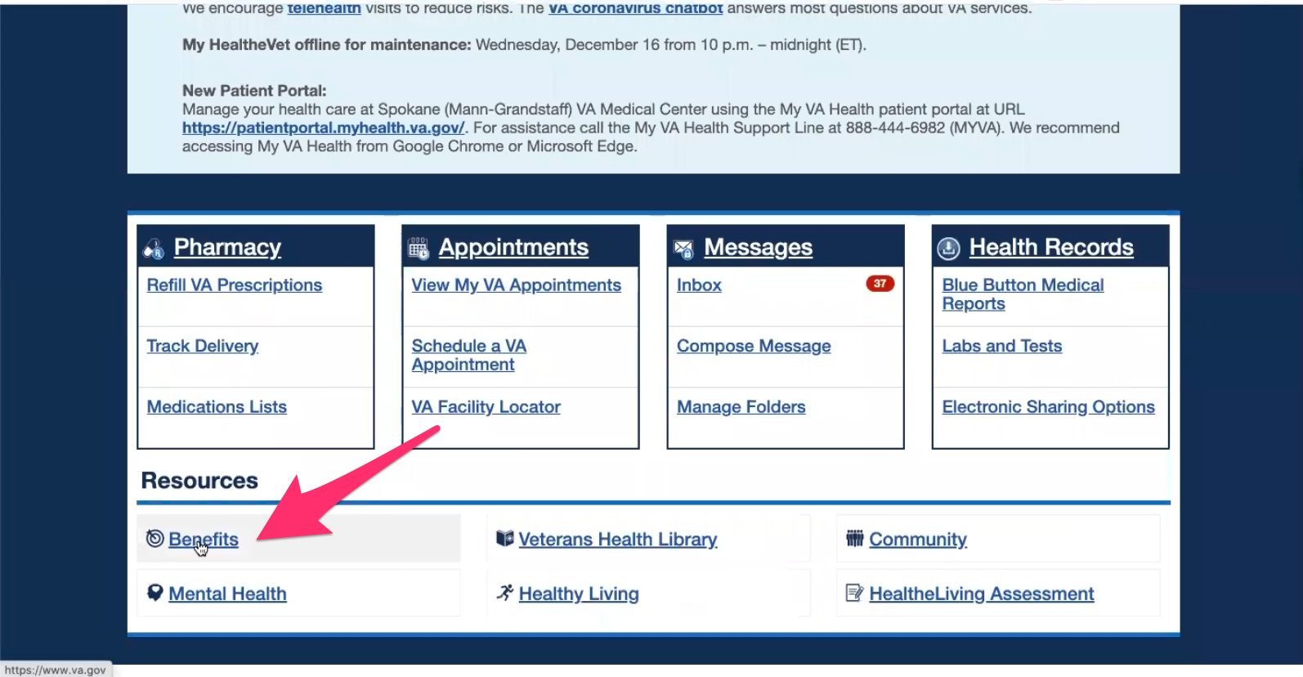

*Moderator goes back to My HealtheVet home page and points out the “Benefits” link under “Resources”.*

*Moderator clicks Benefits link and [VA.gov](http://VA.gov) site loads.*

**Does this look familiar:**

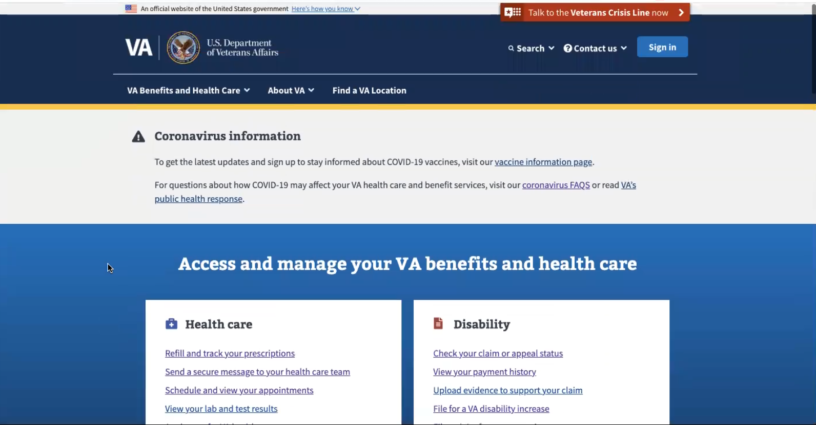

*Moderator shows Participant [VA.gov](http://VA.gov) home page.*

I don’t know if I really have gotten into this part of it.

**Branding and trust (5 minutes)**

Now I’d like to ask for your thoughts on My HealtheVet. (Confirm that participant has used My HealtheVet previously. If not, amend questions below to capture their first impressions while looking at a logged in account.)

1. **On a scale from 1-5, with 1 being very dissatisfied, and 5 being very satisfied, how satisfied are you with My HealtheVet?**

I am pretty satisfied. I would say a 5.

I don’t remember having any issues with the site itself.

If I ever had an issue it’s more like the lab and tests not seeing the records and the doctors not putting it in there.

So I think the site probably a 5.

It’s pretty easy to navigate.

The headers and stuff like, everything is pretty simple to find what you want.

**The labs and test sometimes doesn’t show up:**

I don’t think it is the website because the results of my lab work, if they’re testing to see my kidney values due to one of the meds I am. And I want to see the results before the doctor calls. And I won’t see them so I will just call and they will put the results in. However they do it.

So it’s not really the site itself.

**So maybe it’s on the doctors side their not adding it:**

Yes ma’am.

1. **On a scale from 1-5, with 1 being very low, and 5 being very high, how would you rate your trust in My HealtheVet?**

5. I mean they have all of my information and I don’t have a reason to say less than a 5.

I don’t think I seen that new COVID thing. Like that chat bot thing before. I don’t know if that’s a mobile thing. That’s pretty cool.

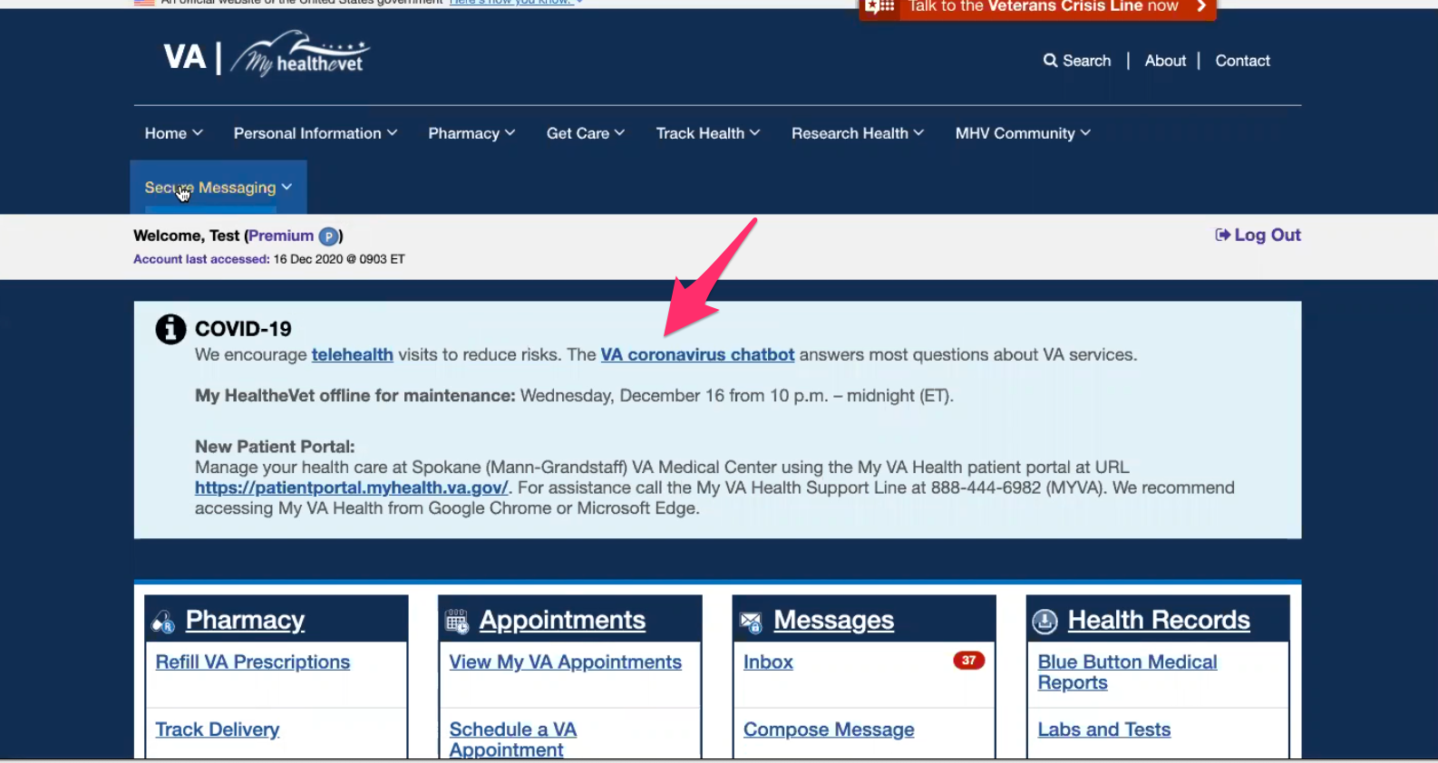

*Participant is referring to “VA coronavirus chatbot” link in “COVID-19” info box at top of My HealtheVet home page.*

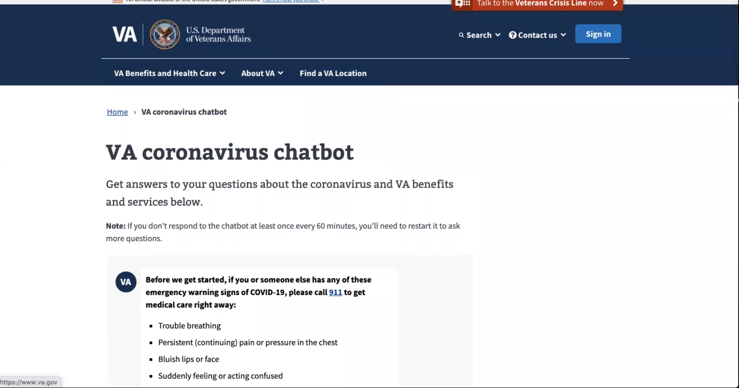

*Moderator clicks on VA coronavirus chatbot link and shows page to Participant.*

**When you say on the mobile thing:**

I don’t think I have seen this on my phone with this site.

**My HealtheVet patient portal (15 minutes)**

Let's take a look at My HealtheVet together.

Moderator will ask participant to share screen if not already, or show logged in My HealtheVet account. **(5 minutes)**

1. **What do you wish this website did that it doesn’t do right now?**

I guess I haven’t messed with it too much because you clicked on one links or boxes and it showed benefits where you can request an increase.

**You mean this link [File for a VA disability increase link on VA home page]:**

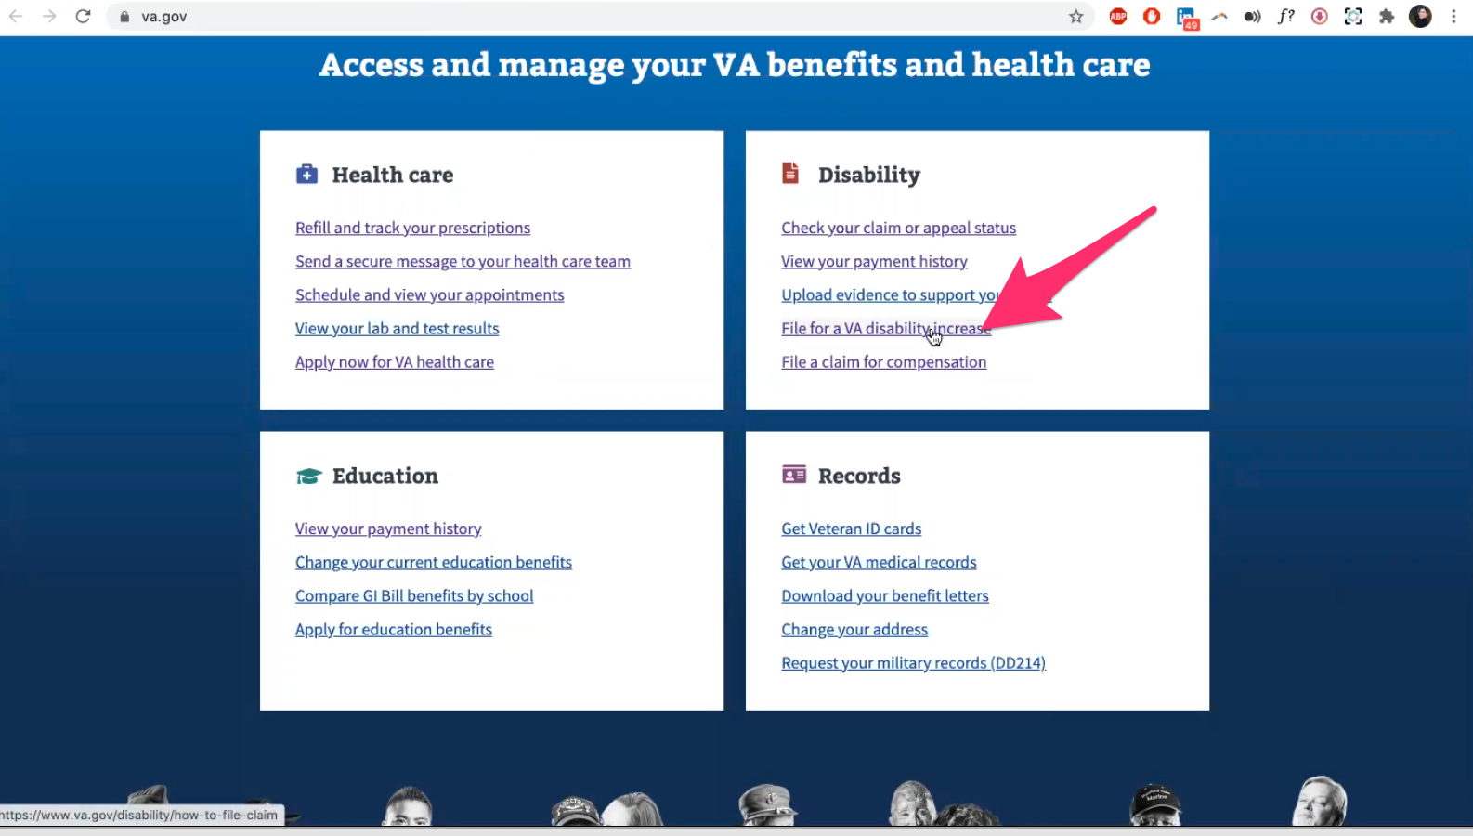

*Moderator goes back to [VA.gov](http://VA.gov) and points out “File for a VA disability increase” link in the “Disability” box on home page.*

So there are things I didn’t know about that are on there. SoI can’t really say if it needs something I guess.

1. **Wife is there to double check that everything is working smoothly and appointments are up to date. When she does that she will use your account:**

Yes Ma’am.

1. I**s there any issues that you know of for her being able to have access, anyway, to make it easier for her to see what you see:**

No, I give her my login information so she sees everything that I see. Yeah ummm.

She navigates it better than I do. More than I am.

Maybe I should have had her in here.

**Thank you and closing (2 minutes)**

**Feedback**: I am going to feel bad for saying I don’t. I’m sorry. I don’t. I know you’re looking for as much information as possible.